**Topcoder - Elasticsearch Feeder Service For Populate Challenge Points Prize In Challenges Index**

# 

# Setup

For the challenge feeder service, run 'mvn clean package' to compile the code and then cd local folder and run './run.sh' to start the services. Before starting the services, you need to first setup the envrionment as following sections.

If you want to push the challenge to the amazon elasticsearch service, configure the

the local/run.sh as:

#export ELASTIC_SEARCH_URL="http://$DOCKER_IP:9200"

export ELASTIC_SEARCH_URL="https://search-your-url-xxxxx.us-east-1.es.amazonaws.com"

export CHALLENGES_INDEX_NAME="challenges"

export AWS_SIGNING_ENABLED=false

export AWS_REGION=us-east-1

export ASW_SERVICE=es

export AWS_ACCESS_KEY=your key here

export AWS_SECRET_KEY=your secret here

You should create the domain at https://aws.amazon.com/cn/elasticsearch-service/.

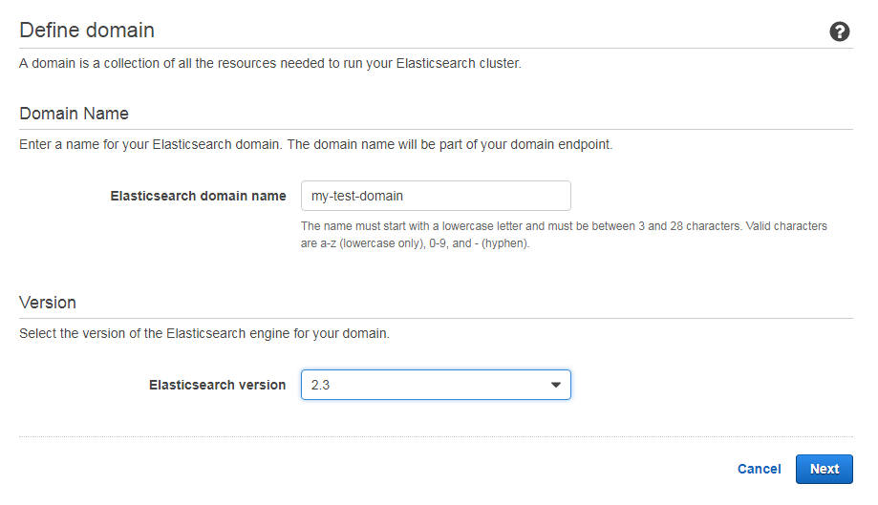

When you are setting up access policy there are many options.

For example if you choose **Allow or deny access to one or more AWS or IAM users**.

You must configure **AWS_ACCESS_KEY**, **AWS_SECRET_KEY**, **AWS_SERVICE**, and  **AWS_REGION** in local/run.sh, and set **AWS_SIGNING_ENABLED** as true.

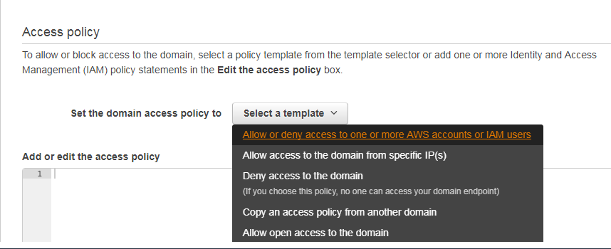

If you chose 'Allow open access to the domain', set AWS_SIGNING_ENABLED to false to disable the credential. Please been noted that this should be just for test purpose.

After you wait about 10 minutes to create domain successfully you can configure **ELASTIC_SEARCH_URL** to the endpoint below:

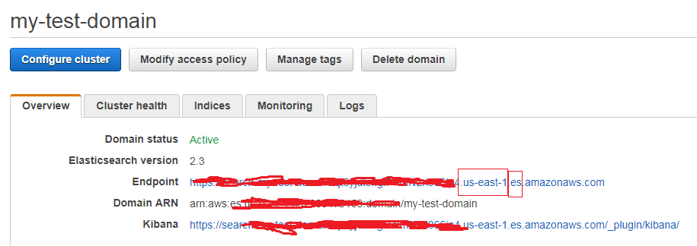

The **AWS_REGION** is us-east-1 and the **AWS_SERVICE** is es.

The direct app docker is https://github.com/appirio-tech/tc-common-tutorials/tree/master/docker/direct-app

Please follow the above url to configure and setup the tc direct app docker.

Then execute the following sql for the tcs_catalog database to make the users agree to all terms:

INSERT INTO tcs_catalog:informix.prize_type_lu (prize_type_id,prize_type_desc) VALUES(16, 'Challenge Points');

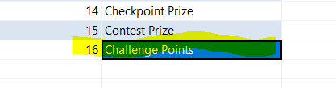

The following verfication section assumes that you have created a challenge with the id 30005522, 30005521.

And run the following sql for the tcs_catalog:

INSERT INTO tcs_catalog:informix.prize

(prize_id, project_id, place, prize_amount, prize_type_id, number_of_submissions, create_user, create_date, modify_user, modify_date)

VALUES(7, 30005522, 1, 50, 16, 0, '12345', '2010-05-21 07:26:30.000', '12345', '2010-05-21 07:26:30.000');

INSERT INTO tcs_catalog:informix.prize

(prize_id, project_id, place, prize_amount, prize_type_id, number_of_submissions, create_user, create_date, modify_user, modify_date)

VALUES(8, 30005522, 1, 150, 16, 0, '12345', '2010-05-21 07:26:30.000', '12345', '2010-05-21 07:26:30.000');

# Verify

Import the docs/ F2F-Topcoder Elasticsearch Service - Populate Challenge Points Prize In Challenges Index.postman_collection.json

Push challenges with id 30005520, 30005522

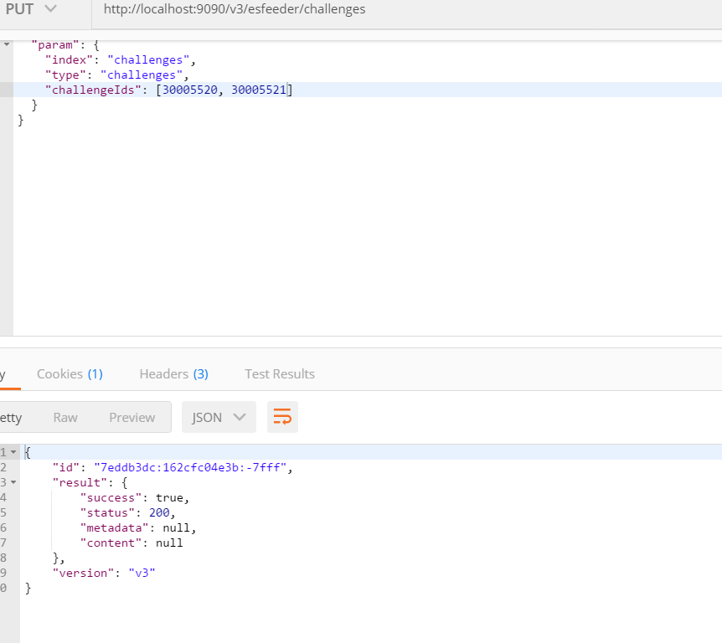

View challenge via ElasticSearch

Change the challenge id in the red rectangle and elastic search URL as highlighted.

